

**GFWC Legislation/Public Policy Quarterly Newsletter 2022-2024**

**Issue No. 8**

**By Debbie Fiore, GFWC New England Region Representative**

**Women’s Suffrage National Monument**

In December 2020, Congress authorized the creation of a federal monument in Washington, D.C. to honor the women’s suffrage movement and the passage of the 19th Amendment. In November 2023 H.R. 1318, the “Women’s Suffrage National Monument Location Act” passed the House of Representatives and authorized the placement of the national monument in the “Reserve”, an area that broadly encompasses the National Mall. GFWC recently sent out an Alert through the Legislative Action Center urging members to ask their elected officials to support H.R. 1319. If you have not already taken action on this Alert, please do so, <https://www.votervoice.net/GFWC/Campaigns/115226/Respond>

The National Mall is where we showcase our history. Of all the monuments, memorials, and statues in the country, less than 4% represent American women’s history, and none are currently located on the National Mall. This monument will serve as a lasting legacy of the longest political movement in American history and honor the generations of women who lobbied, marched, picketed, and protested in their decades-long fight for equality. American women were not handed their right to vote; they fought for and won their right to vote. They never gave up. The monument will serve as a physical reminder of the importance of the right to vote.

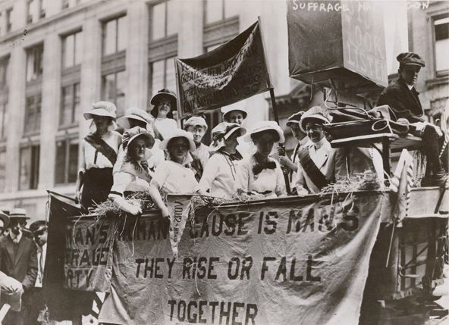

The Women’s Suffrage National Monument Foundation which is tasked with building the monument in Washington D.C. chaired by all the living First Ladies – Dr. Jill Biden, Mrs. Melania Trump, Mrs. Michelle Obama, Mrs. Laura Bush, and Secretary Hillary Rodham Clinton. The First Ladies will spearhead the Foundation’s efforts to ensure that the 36 million people who visit our National Mall each year experience a deeper and more inclusive American story. The Foundation has identified Constitutional Gardens as the optimal location, with the goal to have the monument constructed and completed in time for the United States Semi quincentennial in 2026. The longer it takes to pass this act, the less likelihood that goal will be achieved.

These women deserve to be memorialized within one of America’s most prominent public spaces turning a distant dream into a reality. The vision of the Foundation is to “honor our shared past, uplift our diverse histories, and inspire a new generation of trail blazers to continue the march toward full equality for all. “

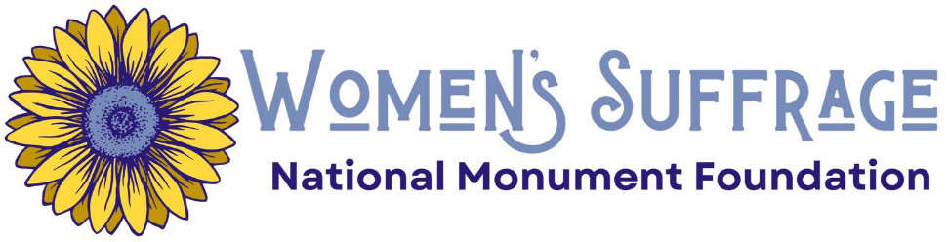

**Federal Regulatory Action Increases**

We have noticed a much-increased volume in federal agencies finalizing notice-and-comment federal regulatory rulemaking processes, based upon legislation passed by Congress. The Biden-Harris Administration is publishing final rules in the *Federal Register* before a mid-May deadline to avoid potential challenges next year under the Congressional Review Act (CRA).

Enacted in 1996, the Congressional Review Act gives Congress the authority to overturn federal rules issued by a presidential administration through a joint resolution of disapproval. If a Congressional Review Act resolution of disapproval passes the House of Representatives and the Senate and is signed by the President, or if Congress overrides a presidential veto of such measure, the rule at issue is overturned. Generally, CRA resolutions are only successful when the White House changes hands to a different political party, and the incoming president’s party also controls Congress. For example, in the early days of the Trump-Pence Administration, the Republican Congress used the CRA to strike down 16 Obama-Biden Administration rules and in the early days of the Biden-Harris Administration, the Democratic Congress overturned three rules issued by the Trump-Pence Administration. Executive Orders issued by the President are not subject to the CRA.

**How the Congressional Review Act works:**

Before a rule can take effect, an agency must notify Congress and the Government Accountability Office (GAO). Upon receipt of the final rule, the House and Senate have 60 days to pass a resolution of disapproval (this includes weekends and holidays but excludes periods where at least one chamber is gone for more than three days pursuant to an adjournment resolution). If the current session of Congress adjourns sine die before the end of the 60 days, the clock is reset, and the new Congress has an additional 60 days starting on the 15th legislative day of the new session. This “lookback” provision is intended to ensure rules filed at the end of a Congress can still be reviewed under the CRA. This prevents an outgoing administration from rushing through final rules before they leave office by making certain Congress has the oversight authority.

The estimated deadline based upon the current congressional calendar is May 22, 2024. All rules finalized after this date may be subject to a resolution of disapproval by the opposing political party.

Examples of recent Final Rules:

* In April 2024, The Environmental Protection Agency (EPA) issued the first-ever national, legally enforceable drinking water standard to protect communities from exposure to harmful PFAS forever chemicals. EPA concurrently announced a further $1 billion to help states and territories implement PFAS testing and treatment at public water systems and to help owners of private wells address PFAS contamination. The Bipartisan Infrastructure Investment and Jobs Act provided this authority and funding. GFWC Resolution 160-120 Water Quality and Supply urges member clubs to support the enforcement of regulation to protect the supply of clean water.
* On April 19, 2024, the Department of Education released a Final Rule under Title IX which prohibits discrimination on the basis of sex, to include sex-based harassment and sexual violence, in education programs or activities receiving federal financial assistance. The final rule also protects against retaliation for students, employees, and others who exercise their Title IX rights, and protects student privacy by prohibiting schools from disclosing personally identifiable information. GFWC Resolution 150-090 Sex and Gender Equity in Education urges member clubs to support Title IX programs.
* In April 2024, the Department of Justice announced the “Engaged in the Business” Final Rule, which makes clear the circumstances in which a person is “engaged in the business” of dealing in firearms and thus required to obtain a federal firearms license, in order to increase compliance with the federal background check requirement for firearm sales by federal firearms licensees. Under this regulation, it will not matter if guns are sold on the Internet, at a gun show, or at a brick-and-mortar store. If you sell guns predominantly to earn a profit, you must be licensed and you must conduct background checks. The Bipartisan Safer Communities Act enhanced background checks and closed loopholes. GFWC Resolution 140-160 Firearms Safety urges member clubs to support “mandatory background checks, waiting periods, and firearms safety education prior to all purchases, including private sales.”

This is the balance of powers provided by democracy. Legislative Advocacy involves not just the passage of a bill into law, but as important, is advocating for the enforcement of the law through necessary regulations.

**Legislative Action Center Alert Statistics**

Thank you to all members who have responded to the GFWC Alerts this Spring. You can still take action on these alerts by going to <https://www.votervoice.net/GFWC/home> . Here is a snapshot of members’ advocacy for each one.

**Shot@Life: Support Global Immunization Programs in FY25:**

1,344 Messages sent by 400 returning advocates and 42 new advocates

16 shares to Facebook

Top Five States Taking Action: Florida, North Carolina, California, New Jersey and Illinois

**Increase FY 2025 Funding for Programs that Address Domestic Violence:**

2,197 Messages sent by 638 returning advocates and 80 new advocates

29 Shares to Facebook

Top Five States Taking Action: Florida, North Carolina, California, New Jersey, and Illinois

**REPORT Act and Kids Online Safety Act:**

2,569 Messages sent by 724 returning advocates and 104 new advocates

19 Shares to Facebook

Top Five States Taking Action: Florida, California, North Carolina, New Jersey, and Georgia

**Build the Women’s Suffrage Monument on the National Mall:**

1,556 Messages sent by 685 returning advocates and 71 new advocates

34 Shares to Facebook

Top Five States Taking Action: California, Florida, North Carolina, New Jersey, and Illinois

**GFWC Legislation and Public Policy Committee 2022-2024**

The members of the GFWC Legislation and Public Policy Committee thank you for promoting advocacy in your states. We are proud that membership in the Legislative Action Center increased this administration, and that our members efforts led to important bills becoming laws.

|  |  |  |  |
| --- | --- | --- | --- |
| Juliet Casper (SC), Chair | Southern | [jcasper9200@gmail.com](mailto:jcasper9200@gmail.com) | c. 843-446-8479 |
| Esther Gartland (OH) | Great Lakes | [gartlanddj@aol.com](mailto:gartlanddj@aol.com) | c. 330-883-8449 |
| Debbie Fiore (CT) | New England | [debfioregfwc@cox.net](mailto:debfioregfwc@cox.net) | c. 860-882-9553 |
| Carolyn Forbes (DE) | Middle Atlantic | [mrschefdjf@aol.com](mailto:mrschefdjf@aol.com) | c. 302-222-6468 |
| Kathy Huggins (NE) | Mississippi Valley | [khuggins555@gmail.com](mailto:khuggins555@gmail.com) | c. 402-517-6196 |
| Sally Harper (NM) | South Central | [saharper@nmsu.edu](mailto:saharper@nmsu.edu) | c. 575-644-7328 |
| Jennifer Jobe (NC) | Southeastern | [jenniferwjobe@gmail.com](mailto:jenniferwjobe@gmail.com) | c. 336-251-2094 |
| Joyce DeCunzo (MT) | Western States | [joycedecunzo2018@gmail.com](mailto:joycedecunzo2018@gmail.com) | c. 406-439-0076 |

### TOGETHER We Advocate For Those In Need

### # GFWCAdvocacy

